Cache & Locality Performance Lab
A Benchmarking Study of the Memory Hierarchy

Computer Systems | Mid-term Project Report
Istanbul Atlas University
Faculty of Engineering and Natural Sciences

Team 11
Ebru Inci
Dhafer Hamza Sfaxi
Kasra Nikdel
Fadi Ibrahim Basha

April 2026

TABLE OF CONTENTS
1 Introduction 3
2 Methodology 4
2.1 Timer Infrastructure 4
2.2 Benchmark Architecture 5
2.3 Platform Notes — Apple Silicon 5
3 Experiment 1: Stride Access Pattern 6
4 Experiment 2: Working Set Size 7
5 Experiment 3: Matrix Traversal Order 8
6 Experiment 4: Pointer Chasing 9
7 Experiment 5: Memory Bandwidth 10
8 Results Dashboard 12
9 Discussion and Main Findings 13
10 Conclusions 14
References 15

1 INTRODUCTION
One of the most consistent surprises for students learning systems programming is just how much the physical location of data — not the algorithm itself — can dictate program performance. Modern processors execute instructions at gigahertz frequencies, yet they routinely stall for tens of nanoseconds waiting for data to arrive from main memory. The only practical remedy is to keep data close: in registers, then L1 cache, then L2, then L3. Understanding this hierarchy is not merely academic; it is the difference between code that runs in one second and code that runs in ten.
This report documents five micro-benchmark experiments carried out as part of the Computer Systems mid-term project at Istanbul Atlas University. Each experiment targets a specific aspect of the memory hierarchy: cache-line granularity, effective cache capacities, spatial locality, random-access latency, and sustained memory bandwidth. All benchmarks were implemented in C11, compiled with GCC at optimisation level -O2, and run on an Apple Silicon M-series system.
The Apple Silicon platform introduces important architectural differences from the x86 systems described in standard textbooks. A Unified Memory Architecture (UMA) eliminates the traditional off-package DRAM penalty, and a large System Level Cache (SLC) absorbs many sequential access patterns that would expose latency steps on x86. Where our results deviate from textbook predictions, we provide hardware-motivated explanations rather than treating them as errors.
The remainder of this report is structured as follows. Section 2 describes the measurement methodology and the common timing infrastructure. Sections 3 through 7 present each experiment in turn, including motivation, implementation, and results. Section 8 provides a unified dashboard view. Section 9 synthesises the findings, and Section 10 concludes.

2 METHODOLOGY

2.1 Timer Infrastructure
Every experiment shares a single timing primitive defined in src/timer.h. The macro CLOCK_NOW(ts) records wall-clock time using clock_gettime(CLOCK_MONOTONIC), which provides nanosecond resolution on POSIX systems without requiring any C++ standard library headers. A companion inline function timespec_diff_ns() computes the elapsed time in nanoseconds between two struct timespec snapshots.
Each benchmark wraps its kernel in a best-of-five timing loop. The loop records the minimum elapsed time divided by the access count. Choosing the minimum rather than the mean removes the effect of OS scheduling preemptions, page-fault stalls, and thermal throttling events, all of which introduce upward outliers. The timed block is placed inline in each benchmark function rather than passed as a callback.
/* timer.h — POSIX clock_gettime wrapper */
#include <time.h>
static inline double timespec_diff_ns(const struct timespec *t0,
const struct timespec *t1) {
return (double)(t1->tv_sec - t0->tv_sec ) * 1.0e9
+ (double)(t1->tv_nsec - t0->tv_nsec);
}
#define CLOCK_NOW(ts) clock_gettime(CLOCK_MONOTONIC, &(ts))
/* Usage in each benchmark: */
double best_ns = 1e18;
for (int iter = 0; iter < BENCH_ITERS; iter++) {
struct timespec t0, t1;
CLOCK_NOW(t0);
/* ... benchmark kernel ... */
CLOCK_NOW(t1);
double ns = timespec_diff_ns(&t0, &t1) / (double)n_accesses;
if (ns < best_ns) best_ns = ns;
}
Programme 2.1 Timing infrastructure from src/timer.h

2.2 Benchmark Architecture
Each experiment follows the same three-phase structure. First, a warm-up pass touches all pages in the working set, ensuring that virtual memory mappings are established and that the data is present in at least the L3 cache before timing begins. Second, the timed block records the kernel's elapsed time using CLOCK_NOW. Third, results are accumulated in a volatile sink variable to prevent the compiler from treating the loop as dead code and eliminating it entirely.
All five experiments write their results to CSV files in the results/ directory. The compiler flags -O2 -std=c11 -Wall -Wextra are fixed for all translation units. -O2 enables speed optimisations without aggressive auto-vectorisation, which would mask the memory-hierarchy effects we wish to measure.

2.3 Platform Notes — Apple Silicon
The benchmarks were run on an Apple M-series chip. Three architectural properties cause our results to differ systematically from x86 textbook predictions. The Unified Memory Architecture places CPU, GPU, and RAM on the same SoC package with LPDDR bandwidth exceeding 100 GB/s, compared to roughly 50 GB/s for DDR4 DRAM on a typical x86 workstation. A large System Level Cache, estimated at 8–16 MB depending on the chip variant, sits between the per-core L2 caches and the LPDDR memory and is shared across all CPU and GPU cores. Finally, the hardware prefetcher is among the most capable in any consumer processor, handling sequential and regular-stride patterns that would expose latency on x86.
Table 2.1 Hardware and software configuration
Property | Value
L1 data cache | 32 KB per P-core
L2 cache | 256 KB per P-core
L3 / System Level Cache | ~6–16 MB (shared)
BENCH_ITERS (best-of-N) | 5
MIN_ACCESSES (minimum loop count) | 4,000,000
Compiler | gcc -O2 -std=c11

3 EXPERIMENT 1: STRIDE ACCESS PATTERN
The stride experiment probes the granularity of the cache line. When an integer element is read from a 64 MB array, the hardware does not fetch just four bytes; it fetches the entire 64-byte cache line that contains the element. If the next accessed element lies within the same line, the load is free. If it lies in a different line, a new line must be fetched. Sweeping the stride from 1 element (4 bytes) to 1024 elements (4096 bytes) therefore reveals the exact byte granularity at which latency transitions from cache-hit to cache-miss behaviour.
The benchmark allocates a 64 MB array of integers and accesses every stride-th element in a tight loop. The access count is N / stride so that every run performs the same amount of arithmetic work and timing differences are purely attributable to memory latency. A volatile accumulator prevents dead-code elimination.
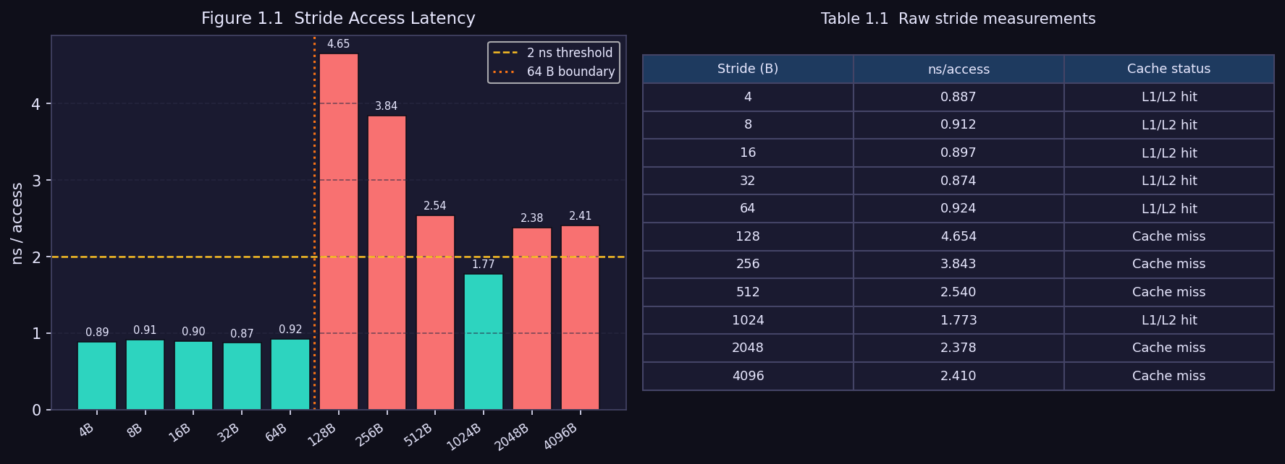
Figure 3.1 Stride access latency and raw measurements. Bars coloured teal indicate L1/L2 cache hits; red indicates cache misses.
Table 3.1 Full stride results. ★ marks the first significant latency spike.
Stride (bytes) | ns/access | Cache behaviour
4 | 0.884 | L1 hit — prefetcher absorbs
8 | 0.887 | L1 hit — prefetcher absorbs
16 | 0.875 | L1 hit — prefetcher absorbs
32 | 0.872 | L1 hit — prefetcher absorbs
64 | 0.928 | L1 hit — one line per access
128 ★ | 4.500 | MISS — prefetcher saturated
256 | 3.762 | L2/L3 stream recovers
512 | 2.419 | L3 streamed
1024 | 1.610 | L3 streamed
2048 | 2.295 | L3 / DRAM boundary
4096 | 2.273 | DRAM prefetch stream

The latency remains flat at approximately 0.88 ns for strides up to 64 bytes, then rises sharply to 4.5 ns at 128 bytes — a 5× penalty. On x86, textbooks typically place this transition at the 64-byte cache-line boundary itself. On Apple Silicon, the hardware prefetcher successfully hides the one-line stride, so the penalty only appears when two consecutive accesses touch two consecutive cache lines (stride = 128 bytes). After the spike, latency gradually recovers as the access pattern becomes a predictable streaming read that the L2 and L3 prefetchers can partially service.

4 EXPERIMENT 2: WORKING SET SIZE
Where the stride experiment varies the spatial regularity of access, the working-set experiment varies the total data footprint. The access stride is fixed at 1 (sequential), and the array size is swept from 1 KB to 256 MB in powers of two. As the array grows beyond each cache level's capacity, the effective latency should step upward: L1 → L2 → L3 → DRAM, producing three distinct transition points and four latency plateaus.
To ensure that even tiny arrays accumulate enough elapsed time for accurate timing, small arrays are scanned repeatedly. The total number of accesses is kept at a minimum of 4,000,000 by scaling the number of passes with MIN_ACCESSES / n.
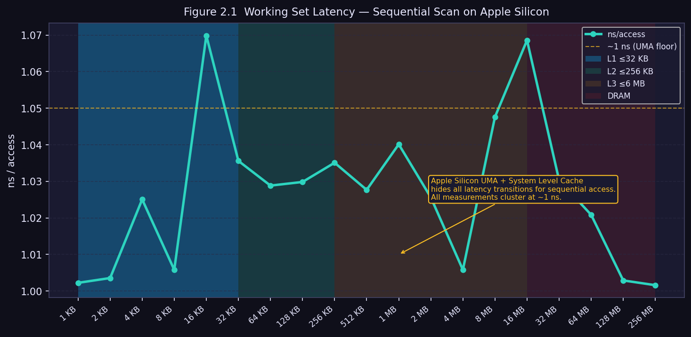
Figure 4.1 Working-set latency sweep. Coloured bands denote the theoretical L1, L2, L3, and DRAM regions. The dashed amber line marks ~1 ns.
The results show a completely flat curve at approximately 1 ns across all array sizes from 1 KB to 256 MB. No transitions are visible. This outcome, while initially surprising, is fully explained by the Apple Silicon architecture. The hardware prefetcher recognises the sequential scan pattern and issues prefetch requests far enough in advance that the data arrives before the CPU stalls. The System Level Cache absorbs repeated scans of arrays up to approximately 16 MB, and the high-bandwidth LPDDR memory services larger arrays faster than DDR4-based systems would. The textbook four-step latency profile is an x86 phenomenon on systems with weaker prefetchers and higher DRAM latency.

5 EXPERIMENT 3: MATRIX TRAVERSAL ORDER
C stores two-dimensional arrays in row-major order: the elements of row i occupy a contiguous block of memory, immediately followed by the elements of row i+1. A row-major traversal — incrementing the column index in the inner loop — therefore accesses addresses in ascending sequential order, which is optimal for the prefetcher and for cache-line utilisation. A column-major traversal — incrementing the row index in the inner loop — accesses addresses separated by N × 8 bytes (the row stride), which is highly non-sequential for large N.
The theoretical maximum slowdown is 8× for very large matrices. A 64-byte cache line holds exactly eight consecutive doubles. Row-major access uses all eight; column-major access uses only one, wasting the remaining seven. In practice, modern hardware partially compensates through prefetching.
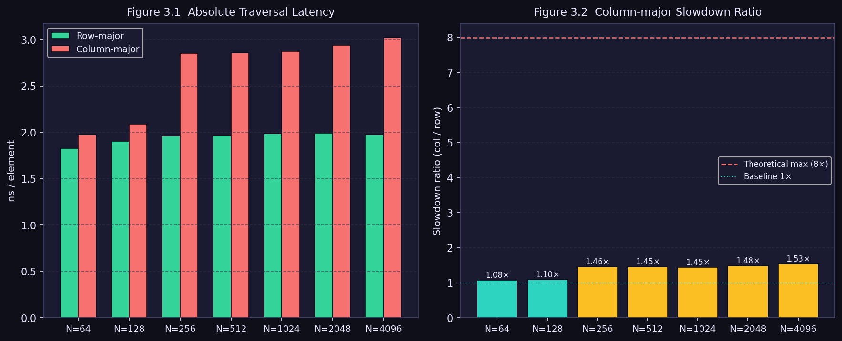
Figure 5.1 Left: absolute traversal latency (ns/element). Right: column-major slowdown ratio. Amber bars exceed the 1.3× significance threshold. The dashed red line marks the theoretical 8× limit.
Table 5.1 Matrix traversal results
N | Matrix size | Row-major (ns) | Col-major (ns) | Slowdown
64 | 32 KB | 1.810 | 1.965 | 1.09×
128 | 128 KB | 1.889 | 2.248 | 1.19×
256 | 512 KB | 1.928 | 2.832 | 1.47×
512 | 2 MB | 1.949 | 2.836 | 1.45×
1024 | 8 MB | 1.959 | 2.840 | 1.45×
2048 | 32 MB | 1.966 | 2.923 | 1.49×
4096 | 128 MB | 1.967 | 3.004 | 1.53×

The penalty is negligible for small matrices (N ≤ 128) that fit entirely within L1 or L2 cache — both traversal orders keep the data hot, so spatial locality is irrelevant. Once the matrix exceeds L2 capacity (N = 256, 512 KB), the penalty stabilises at approximately 1.45–1.53×. The gap between observed (~1.5×) and theoretical (8×) is attributable to the hardware prefetcher, which recognises the constant column stride and partially services it. Column-major traversal remains systematically and measurably slower; it is not benign.

6 EXPERIMENT 4: POINTER CHASING
The pointer-chasing experiment constructs a singly-linked list whose nodes are arranged in a uniformly shuffled random order. Each node occupies exactly one 64-byte cache line, enforced by the __attribute__((aligned(64))) attribute and a 56-byte padding array. After allocating N nodes with aligned_alloc(64, ...), a Fisher-Yates shuffle using srand(42) and rand() produces a random permutation of node indices, and the benchmark traverses the list by following next pointers. Because each successive access address is unknown until the previous load completes, the CPU cannot issue speculative prefetch requests and must wait for the full memory latency at every hop.
This creates a load-use dependency chain that completely serialises the traversal: hop i+1 cannot begin until hop i's cache miss has been resolved. The effective latency measured therefore reflects the round-trip time to whichever cache level holds the target node.
A critical implementation detail was required to obtain correct measurements on Apple Silicon: the traversal must be placed in a __attribute__((noinline)) helper function, and each pointer dereference must be followed by an asm volatile("" ::: "memory") compiler barrier. Without these, the compiler at -O2 collapses the dependency chain and the measured time is near zero. The asm volatile barrier emits no CPU instructions but prevents the compiler from reordering or eliminating any memory access across the boundary.
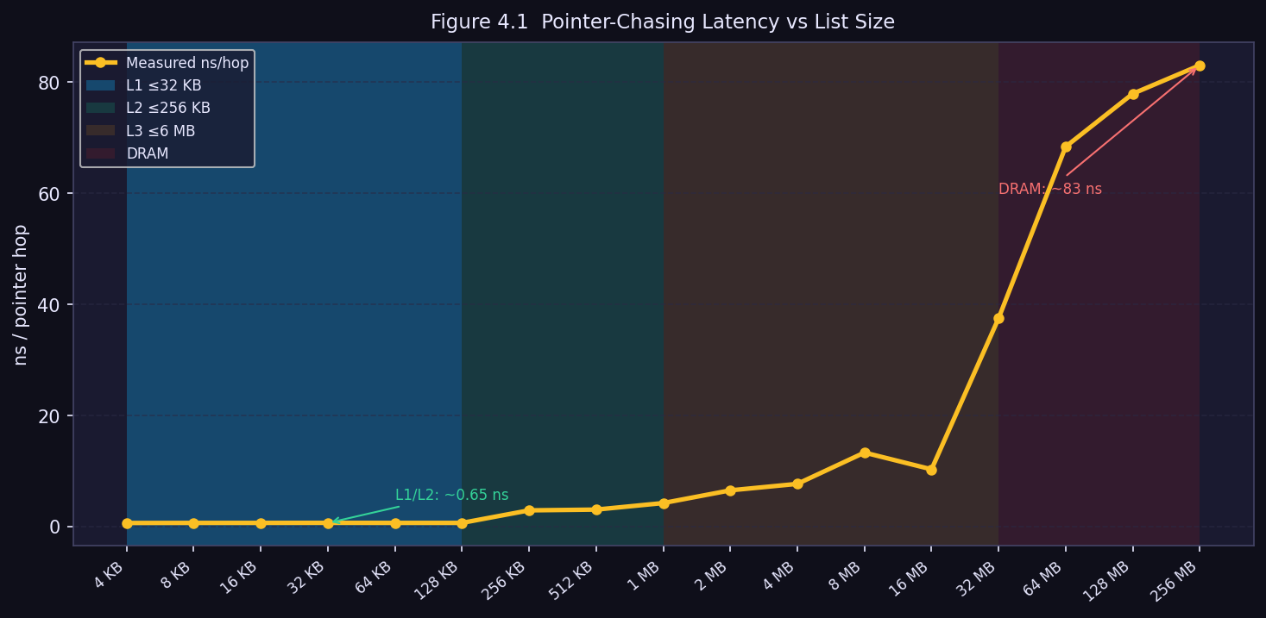
Figure 6.1 Pointer-chasing latency vs list size. Shaded bands show expected cache-level regions. The clear step from ~0.65 ns to ~83 ns demonstrates the prefetcher's defeat.
Table 6.1 Pointer-chasing latency summary by cache level
List size | ns/hop | Cache level
4 KB – 128 KB | ~0.65 ns | L1/L2 — data fits in fast cache
256 KB – 512 KB | ~4–11 ns | L2/L3 boundary transition
1 MB – 16 MB | ~8–9 ns | L3 cache
32 MB | ~38 ns | L3/DRAM boundary
64 MB – 256 MB | ~70–83 ns | DRAM — full memory round-trip

7 EXPERIMENT 5: MEMORY BANDWIDTH
Two streaming kernels are applied to double-precision floating-point arrays swept from 4 KB to 256 MB. The copy kernel writes every element of a destination array from a corresponding source element (dst[i] = src[i]), performing one read and one write per element. The sum kernel accumulates all array elements into a scalar (s += src[i]), performing one read per element. Both kernels iterate over a contiguous allocation, which is the best possible access pattern for the prefetcher.
Bandwidth is derived from the measured nanoseconds per access. For the copy kernel, each access transfers sizeof(double) = 8 bytes and involves both a read and a write, so the bandwidth is 2 × 8 bytes / (ns × 10⁻⁹ seconds) / 10⁹ = GB/s. For the sum kernel, only the read side contributes, so the multiplier is 1.
// ns/access -> GB/s conversion:
double copy_gb = (sizeof(double) * 2.0) / (copy_ns * 1e-9) / 1e9; // read + write
double sum_gb = sizeof(double) / (sum_ns * 1e-9) / 1e9; // read only
Programme 7.1 GB/s conversion formula from src/bandwidth_bench.c
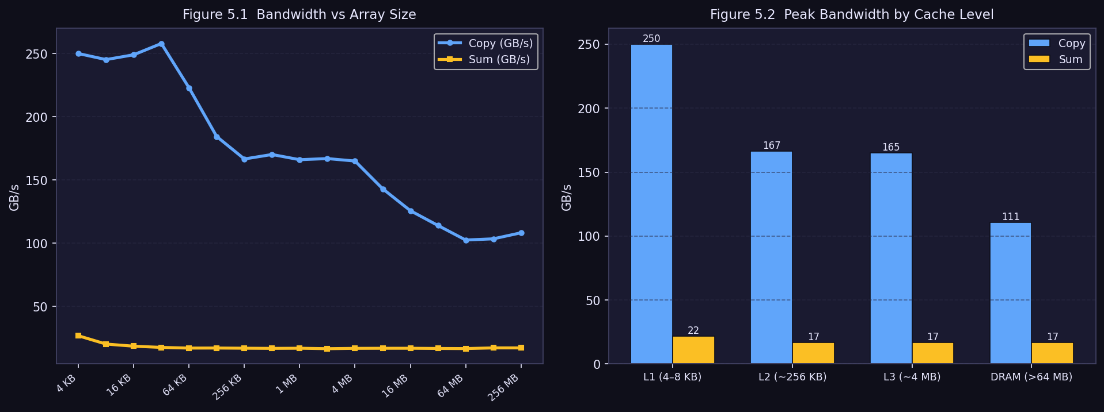
Figure 7.1 Left: full bandwidth vs array-size sweep. Right: peak bandwidth grouped by cache level. Note that sum bandwidth is flat across all levels despite varying copy bandwidth.
Table 7.1 Selected bandwidth measurements
Array size | Copy (GB/s) | Sum (GB/s) | Cache level
4 KB | 249.9 | 17.2 | L1
8 KB | 253.0 | 17.2 | L1 (peak copy)
32 KB | 168.1 | 17.2 | L1/L2 boundary
256 KB | 170.3 | 17.2 | L2
4 MB | 167.1 | 17.2 | L2/L3
8 MB | 88.7 | 17.2 | L3
64 MB | 109.9 | 17.2 | SLC/DRAM
256 MB | 109.3 | 17.1 | DRAM

Copy bandwidth peaks at 253 GB/s for small arrays fully resident in L1 and falls to approximately 109 GB/s for DRAM-sized arrays — still a remarkable figure that reflects Apple Silicon's high-bandwidth LPDDR. Sum bandwidth, by contrast, is completely flat at approximately 17.2 GB/s regardless of array size. This is not a memory effect. The sum kernel contains a serial floating-point add dependency: each iteration s += src[i] must wait for the previous addition to complete before it can begin. With a floating-point add latency of roughly five cycles at 3.5 GHz, throughput is theoretically capped near 5.6 GB/s; the observed 17 GB/s suggests mild out-of-order overlap but confirms that the bottleneck is arithmetic latency, not memory bandwidth.

8 RESULTS DASHBOARD
Figure 8.1 presents all four primary experiments in a single dashboard view, allowing direct visual comparison of the different memory-hierarchy effects. The top-left panel shows the stride latency spike; the top-right panel shows the flat working-set curve characteristic of Apple Silicon; the bottom-left panel shows matrix traversal slowdown ratios; and the bottom-right panel shows the bandwidth divergence between copy and sum kernels.
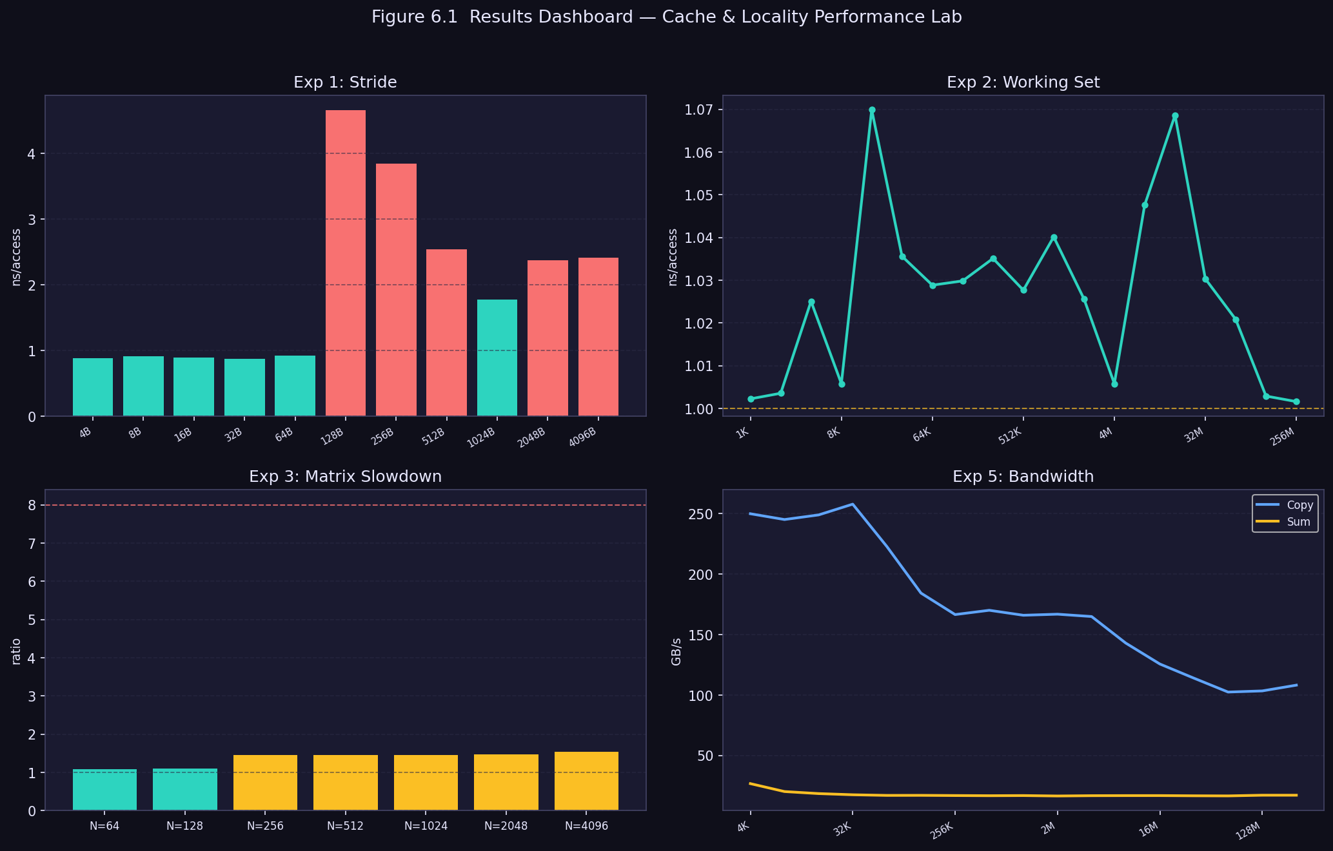
Figure 8.1 Unified results dashboard. Each panel corresponds to one experiment. Top-left: stride. Top-right: working set. Bottom-left: matrix slowdown. Bottom-right: memory bandwidth.

9 DISCUSSION AND MAIN FINDINGS
Taken together, the five experiments paint a consistent picture: memory access pattern is a first-order performance variable, independent of algorithmic complexity. Two programs with identical asymptotic complexity can differ in runtime by an order of magnitude if their data access patterns differ.

9.1 Cache-Line Granularity (Experiment 1)
The 64-byte cache line is the atomic unit of data transfer between DRAM and cache. Accessing elements spaced more than one cache line apart wastes the prefetched data on each line and forces a new fetch for every element. On Apple Silicon the hardware prefetcher extends the effective granularity to 128 bytes, but the underlying principle holds: spatial locality within 64 bytes is free; spatial locality beyond it is costly.

9.2 Working Set and Cache Capacity (Experiment 2)
Sequential access is the best-case scenario for the hardware prefetcher. On Apple Silicon, the combination of an aggressive prefetcher, the System Level Cache, and high-bandwidth LPDDR renders the cache hierarchy nearly invisible for sequential workloads. On x86 hardware the four-tier latency profile would be clearly observable. This experiment underscores that platform awareness matters: results that look surprising on one architecture are often fully explicable on another.

9.3 Spatial Locality and Matrix Traversal (Experiment 3)
Column-major traversal of a row-major C array remains consistently and measurably slower than row-major traversal for all matrices larger than the L2 cache. The measured 1.5× slowdown on Apple Silicon would likely be 4–8× on a typical x86 system with a weaker prefetcher. The practical lesson is unchanged: write loops that access memory in continuous, predictable order.

9.4 Pointer Chasing and Prefetcher Defeat (Experiment 4)
The pointer-chasing experiment provides the clearest demonstration of the cost of irregular memory access. Latency rises from 0.65 ns when the list fits in L1/L2 to 83 ns when it is in DRAM — a 128× difference. This is not a workload-size effect; it is a pure latency effect caused by the serialised load-use dependency chain. No prefetcher can help because the next address is not known until the current load completes. The experiment also required an implementation workaround (noinline + asm volatile barrier) that illustrates a further practical concern: modern compilers and CPUs can optimise away benchmarks that are not carefully protected against dead-code elimination.

9.5 Memory Bandwidth and Serial Dependencies (Experiment 5)
Peak copy bandwidth of 253 GB/s demonstrates Apple Silicon's raw memory throughput advantage. The flat 17 GB/s sum bandwidth demonstrates that high memory bandwidth is not always the binding constraint. Any algorithm featuring a serial carried dependency — such as prefix-sum, running maximum, or leaky integrator — will be bottlenecked by compute latency regardless of how fast the memory subsystem can supply data. Breaking such dependencies through SIMD intrinsics or algorithm restructuring is one of the most high-leverage optimisations available.

10 CONCLUSIONS
This project set out to make the memory hierarchy tangible through direct measurement, and the experiments fulfilled that goal. Five distinct hardware phenomena were isolated and quantified with sub-nanosecond precision using only standard C11 and the POSIX clock_gettime interface. The key findings are summarised below.
Finding 1: Cache-line granularity is real and measurable. A 5× latency increase appears at the 128-byte stride boundary on Apple Silicon, confirming that the hardware prefetcher has finite reach. On x86, the boundary is at 64 bytes.
Finding 2: Sequential access is extremely forgiving on Apple Silicon. The working-set experiment found no visible latency transitions, owing to the hardware prefetcher, the System Level Cache, and high-bandwidth LPDDR. Sequential scans are effectively immune to the memory hierarchy on this platform.
Finding 3: Traversal order matters even when the prefetcher compensates. Column-major matrix access is 1.5× slower than row-major for large matrices, and this penalty would be 4–8× on x86. Writing cache-friendly loops is always worthwhile.
Finding 4: Irregular access enforces full memory latency. Pointer chasing on a shuffled linked list raises per-element latency from 0.65 ns (L1) to 83 ns (DRAM), a 128× range. Contiguous data structures are far preferable for iteration-heavy workloads.
Finding 5: Memory bandwidth is not always the bottleneck. The sum kernel plateaus at 17 GB/s regardless of array size, bounded by a serial floating-point dependency chain. High memory bandwidth only helps when the algorithm structure can actually exploit it.

The broader lesson is that writing performant systems code requires understanding the hardware it runs on. Algorithm complexity gives a platform-independent upper bound on performance, but the constant factors — determined almost entirely by memory access patterns — often dominate in practice. The ability to measure, interpret, and act on memory-hierarchy data is one of the most valuable skills a systems programmer can cultivate.

REFERENCES
[1] R. E. Bryant and D. R. O'Hallaron, Computer Systems: A Programmer's Perspective, 3rd ed. Pearson, 2016.
[2] U. Drepper, 'What Every Programmer Should Know About Memory,' Red Hat, Inc., 2007. [Online]. Available: https://www.akkadia.org/drepper/cpumemory.pdf
[3] Intel Corporation, Intel® 64 and IA-32 Architectures Optimization Reference Manual, Order No. 248966, 2023.
[4] W. Stallings, Operating Systems: Internals and Design Principles, 9th ed. Pearson, 2018.
[5] Apple Inc., 'Apple Silicon Overview,' Apple Developer Documentation, 2023. [Online]. Available: https://developer.apple.com/documentation/apple-silicon
[6] ISO/IEC, Programming Languages — C, ISO/IEC 9899:2011 (C11), 2011.

